**The task is to replicate the mockup with good functionality.**

**Please note that we are not expecting an identical copy, but rather a version of it you think is best.**

**Desktop Version**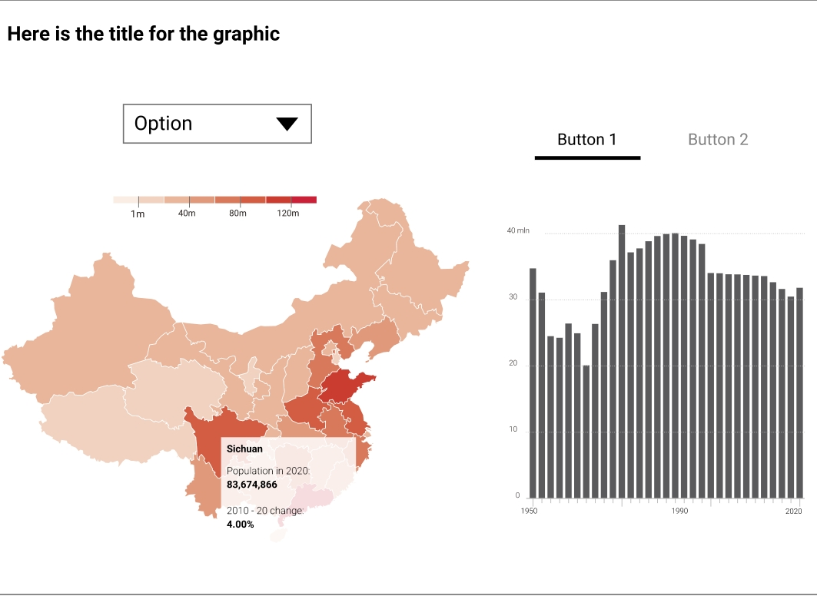 [Mockup Link](https://xd.adobe.com/view/19804975-2a95-47fb-af6f-59b96c2c3db5-4cd3/)  
  
Mockup includes mobile and desktop version

[Data Source Link](https://docs.google.com/spreadsheets/d/1yYRgk7wLHrEZ-yz9cOayMxwVp9yM9PNhLBOYHsfVBqw/edit#gid=0)

Source: [National People's Congress](http://www.npc.gov.cn/npc/dbmd13/dbmd.shtml)

* Map on hover displays the following information in a clean format
* Map interactivity
* Map transitioning
* Map responsiveness
* Buttons are interactive.
* Smooth movements
* Cleanliness of UI & UX design
* Chart interactivity, transition, responsiveness

Tooltip should display

* Population
* Men & women in each delegation
* % of change from latest year

**Map should only contain latest population count along with men and women in each delegation clearly & cleanly stated**

**Bar/Line Chart should include population charts. It should work for each province as you click on the map**

**Front End tech stack to be used**: HTML, CSS, JS,

Along with any framework you find comfortable.We usually we use JQuery but do not mind others

Any Chart library is fine

D3.js

Highcharts

Google Charts

**Requirements:**

* Responsive and works well with several breakpoints and mobile devices.
* Compatible with all browsers
  + Desktop:
    - IE 11
    - Microsoft Edge v90
    - Firefox v90
    - Chrome v90
    - Safari v13
    - Opera v72
* Mobile
  + Safari on IOS 14
  + Android Browser v92
  + Opera mobile v64
    - Chrome for Android v92
    - Chrome for IOS